1) Create one Jenkins job using the below code and create three stages.

stage1: Git clone to download the source code.

stage2: SonarQube Integration to check the quality of code

stage3: Slack Integration to send the alerts to slack.

URL:- <https://github.com/Tarakiran/sabear_simplecutomerapp.git>

Description :--

First we have to create one Ec2 instance t2-large with 20gb volume

Install SonarQube

For installing SonarQube we need java

Yum install java-1.8\* -y ------> command

After installing java install SonarQube using docker

Commands to install SonarQube using docker

Yum install –y docker

Systemctl enable docker

Systemctl start docker

Systemctl status docker

docker pull sonarqube

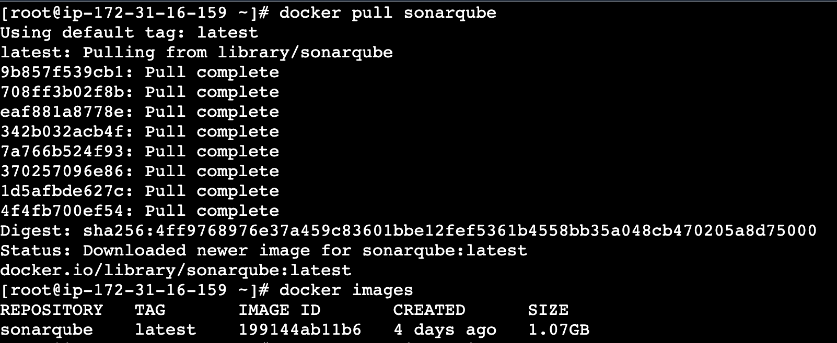

docker images

docker run -itd -p 9000:9000 sonarqube ---> to run sonarqube

Sonarqube default port no 9000

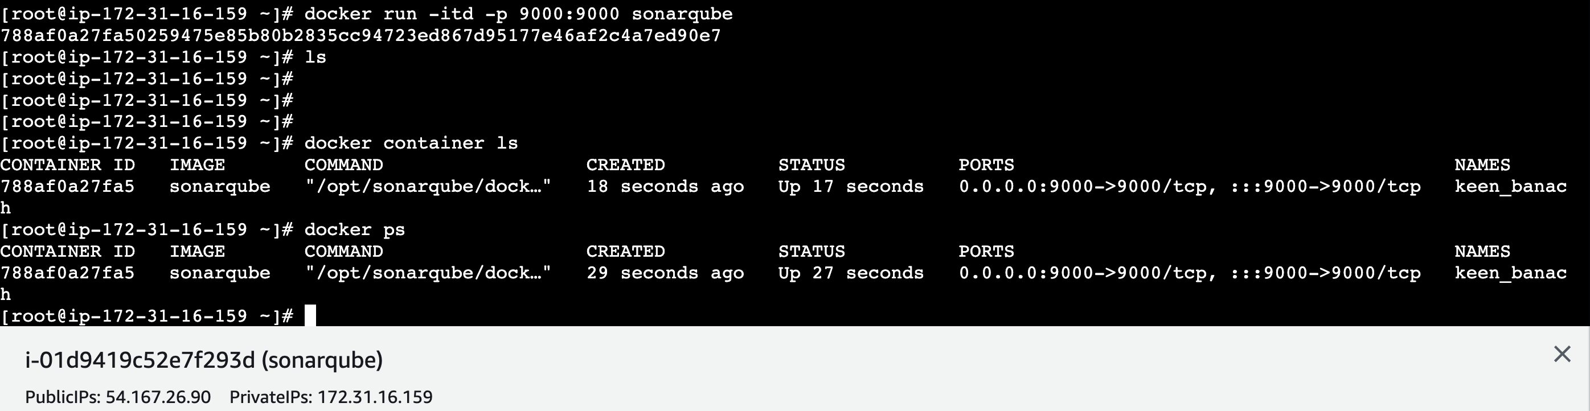

After sonarqube running we have to copy the public ip address with port no 9000

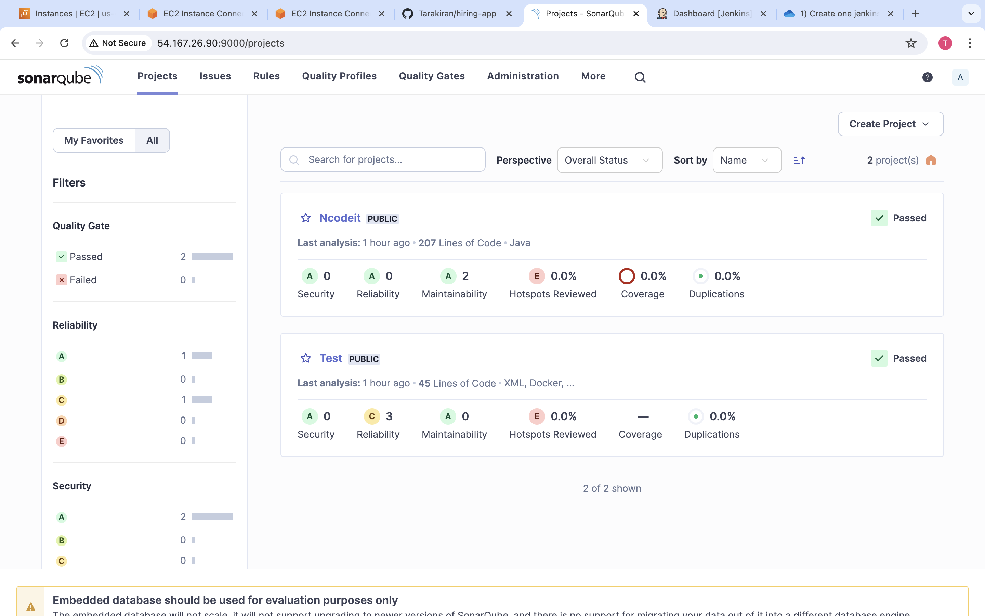

Generate a token in sonarqube copy the access key

Create a new credential in jenkins credentials with name sonar and add the token generated in sonarqube

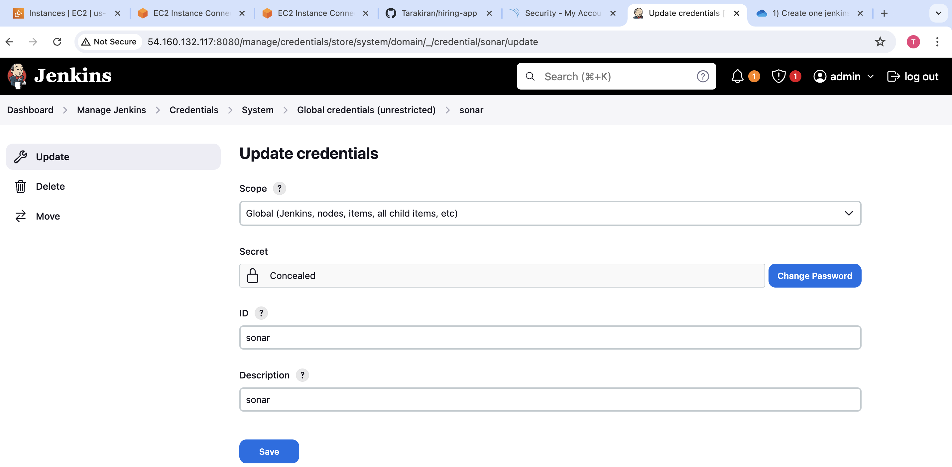

Install sonar scanner plugin in jenkins

Go to Dashboard--->Manage Jenkins--->system setup sonarqube installations with sonarqube url with credentials

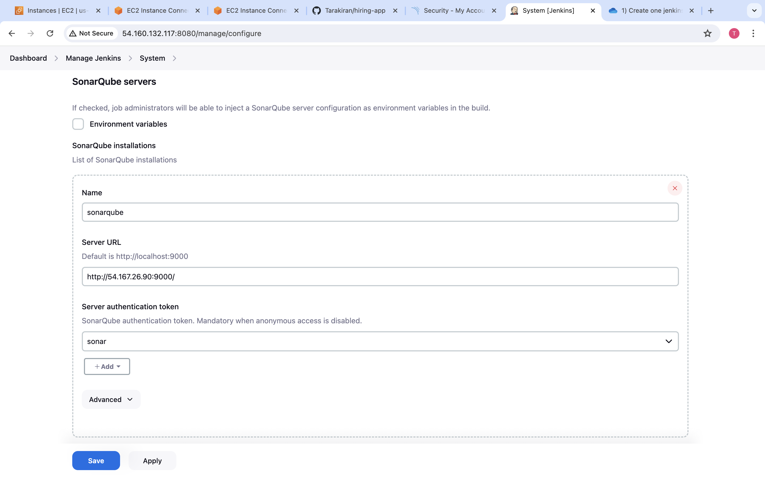

Setup sonarqube installations in Dashboard --> Manage jenkins-->Tools

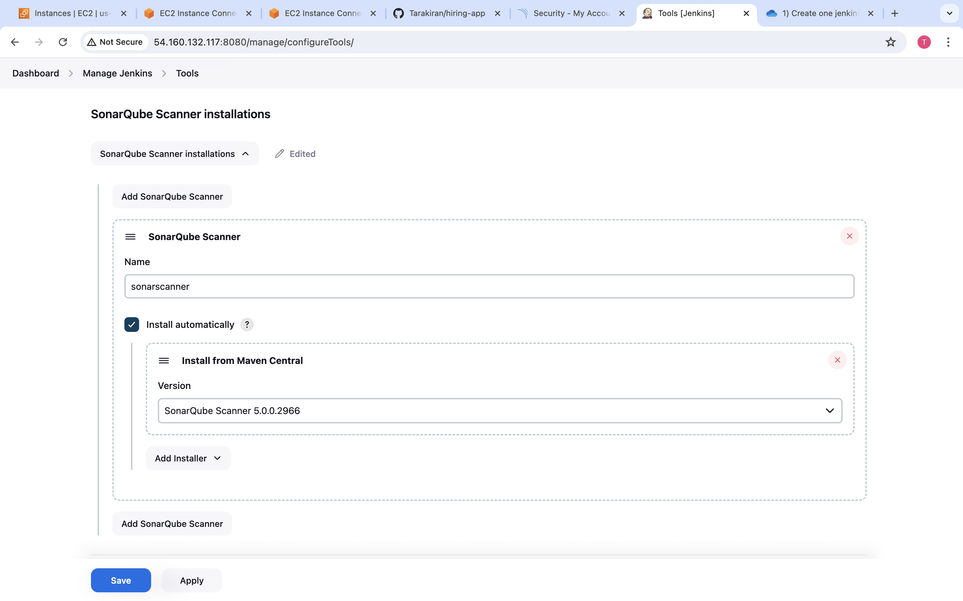 Create a job with project name in jenkins attach repository URL 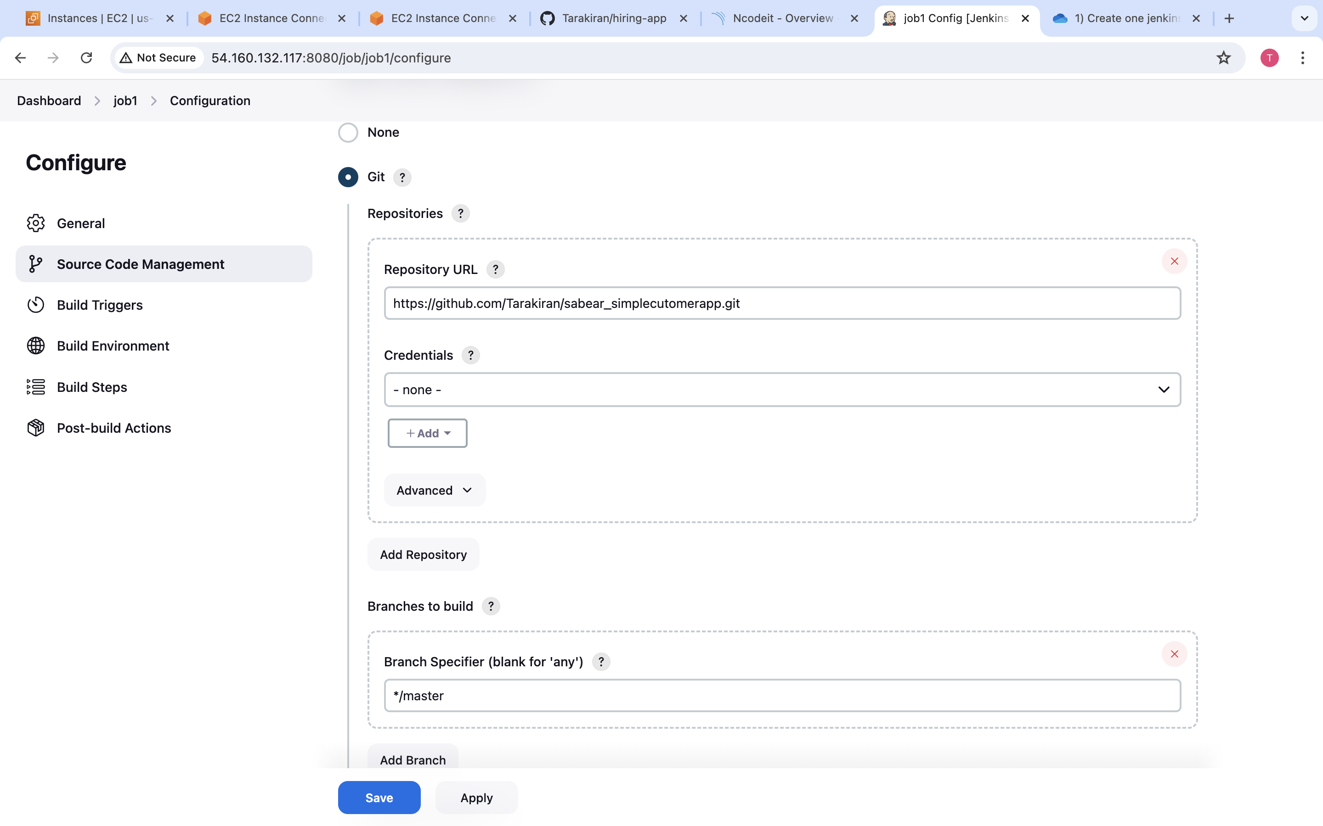

Go to Build steps Execute sonarqube scanner in configuration path of created job

Add Analysis Properties which was there in repository

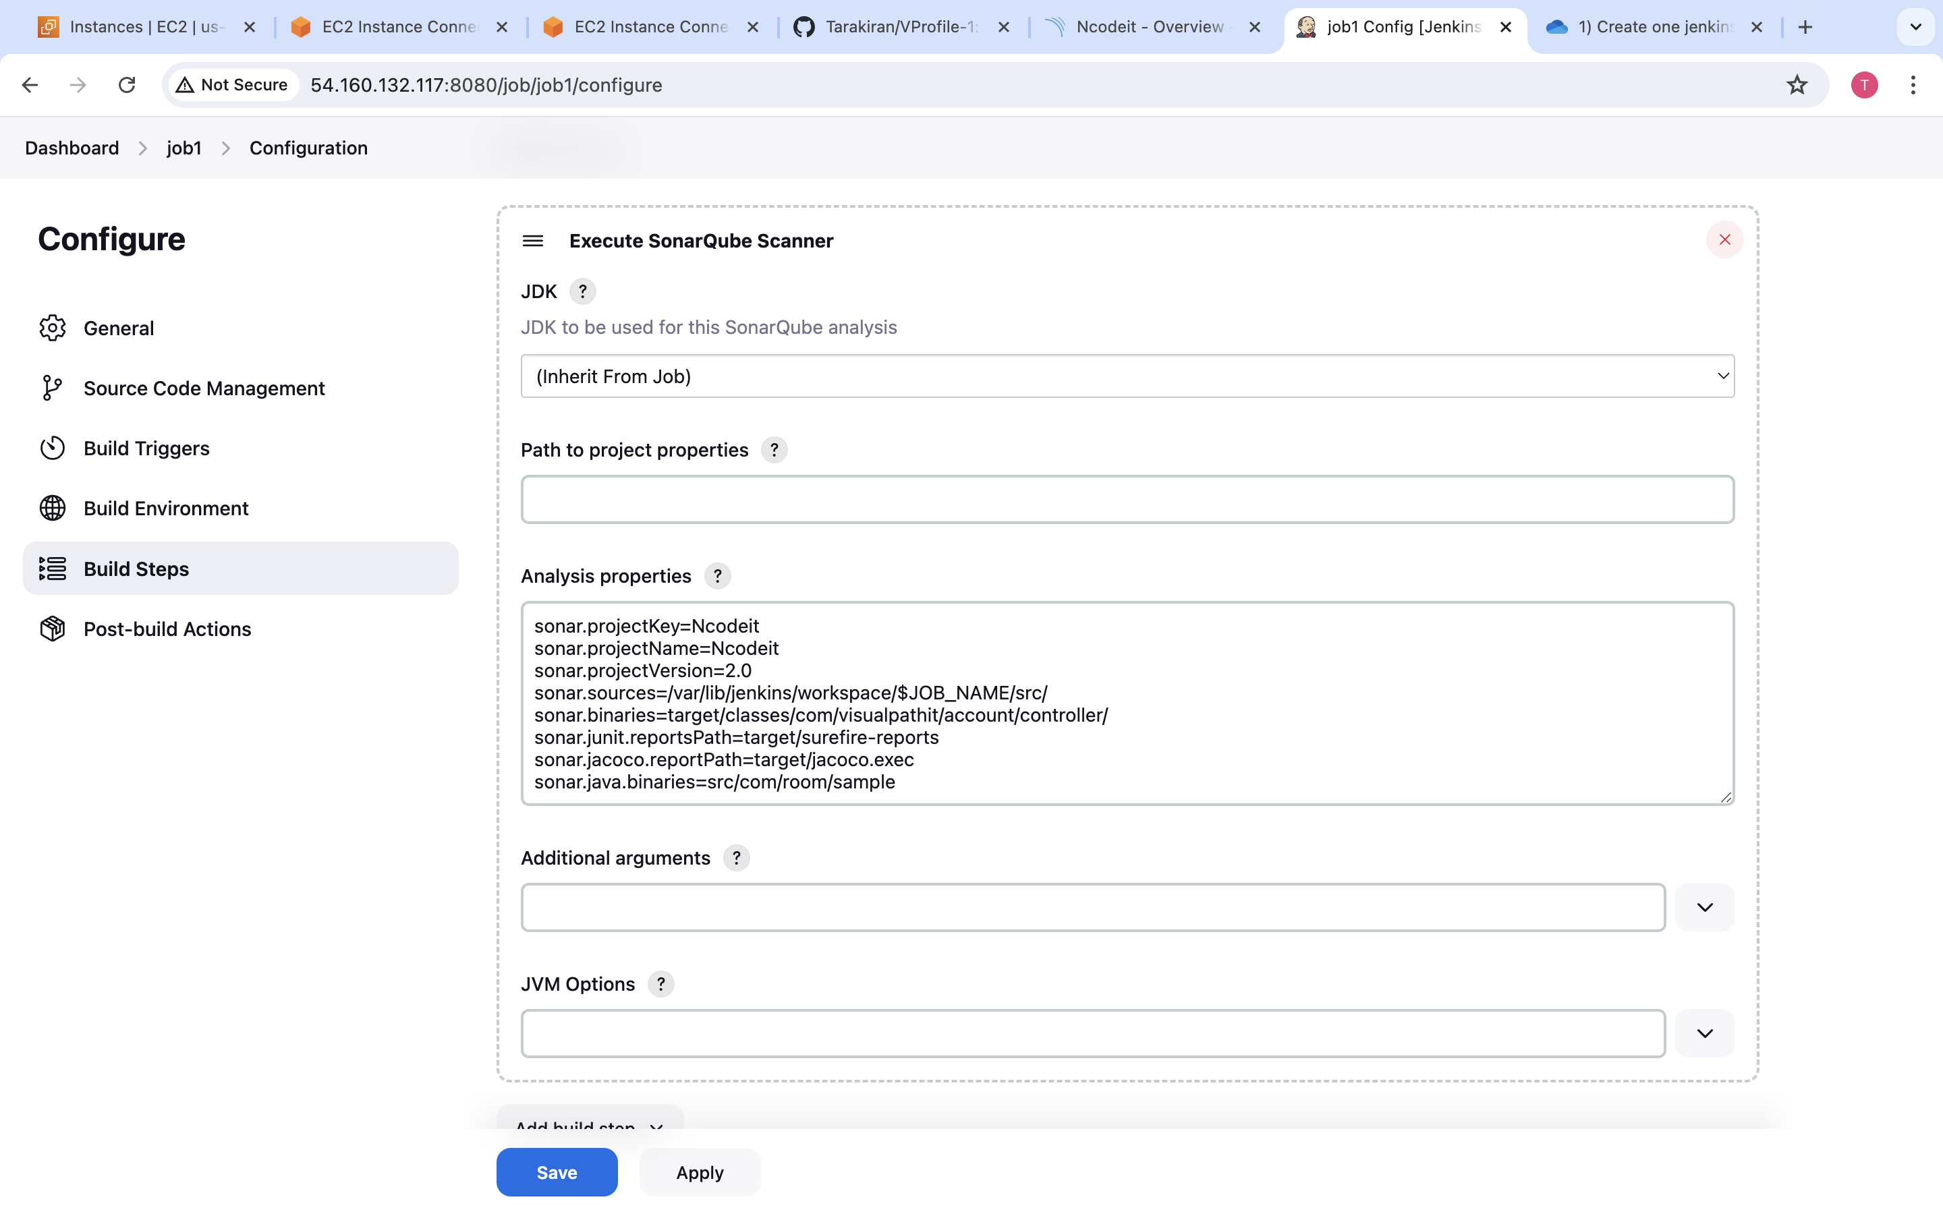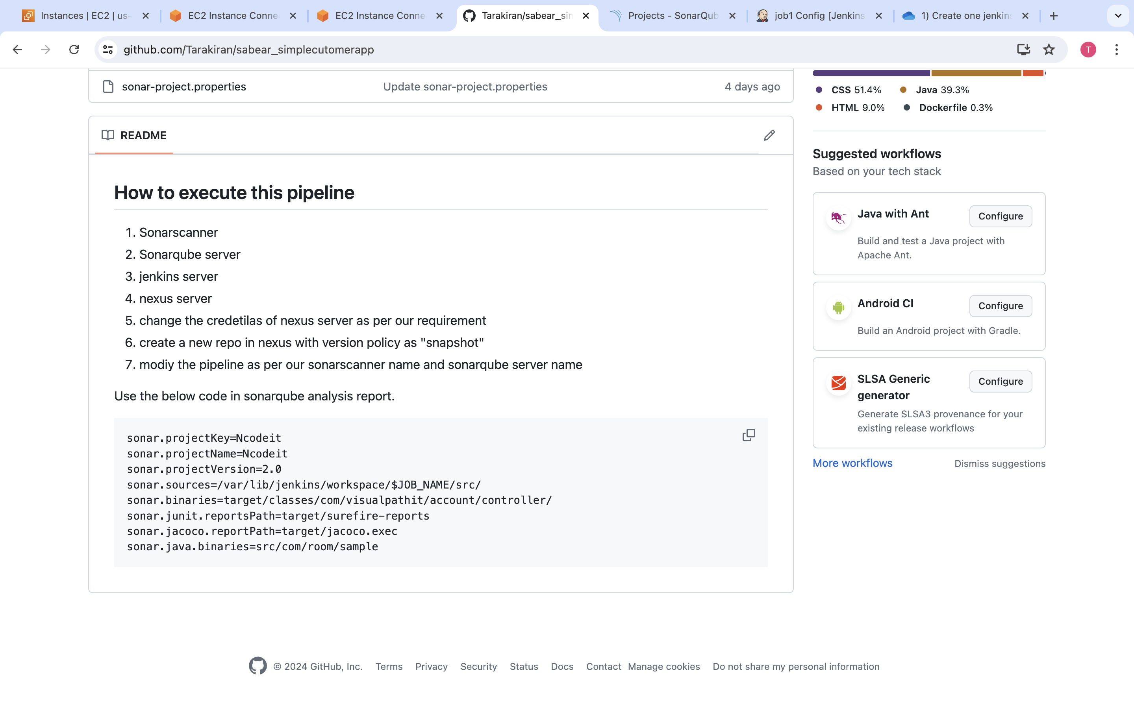

After all the setup was done run the job

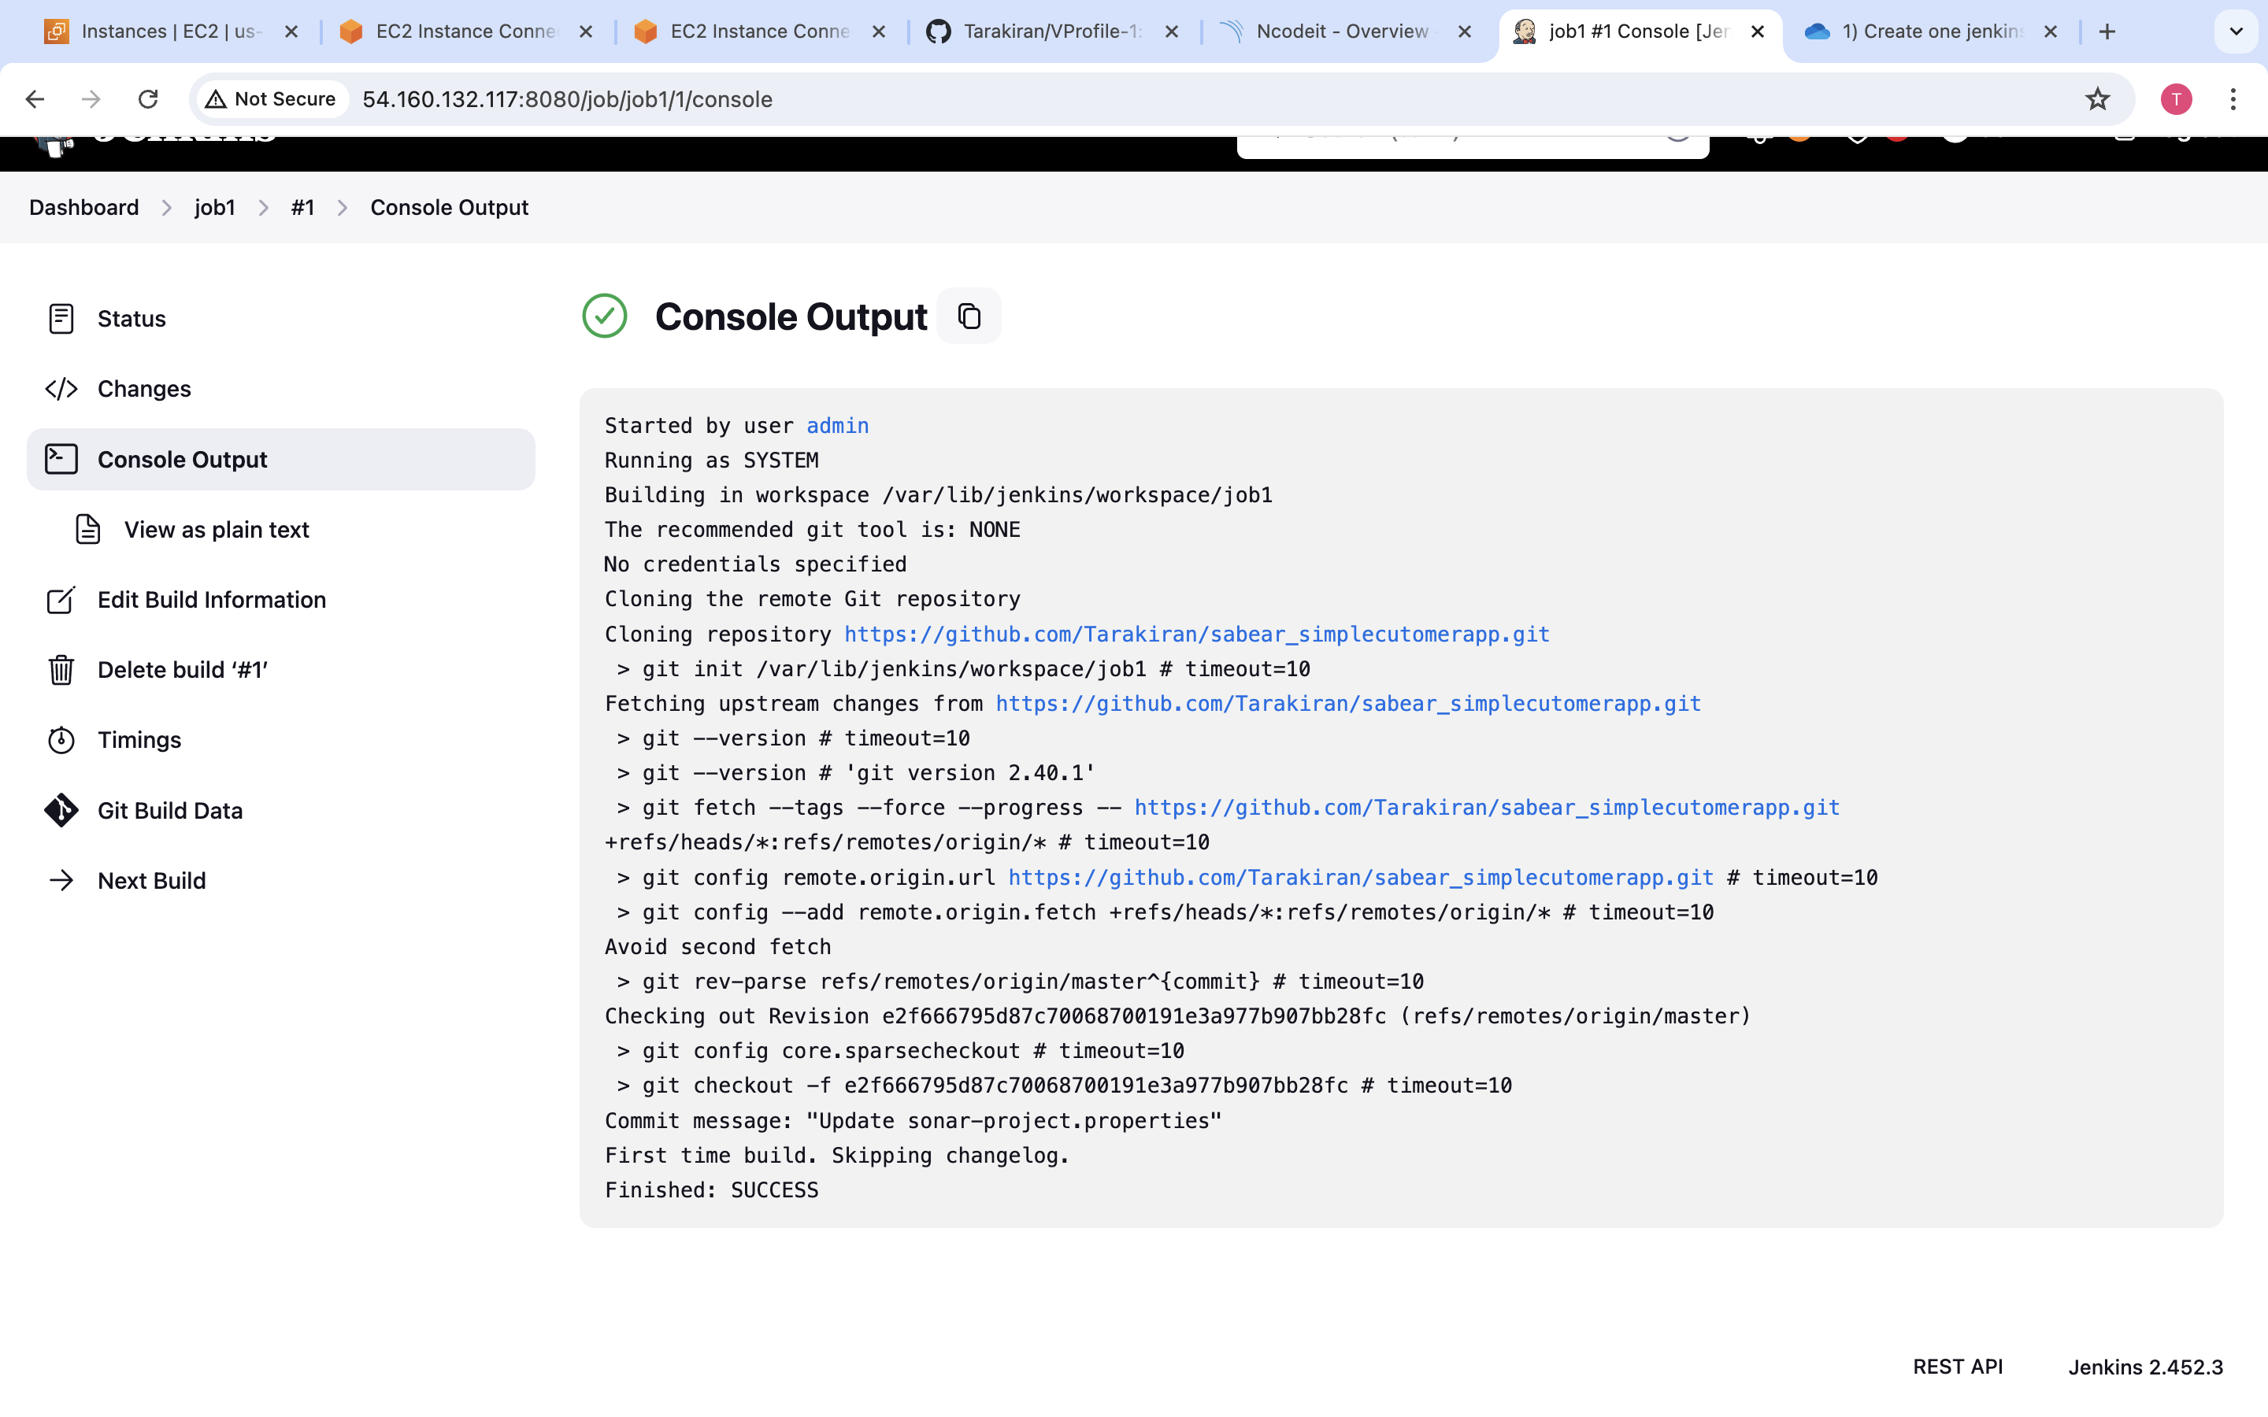

Go to sonarqube server check the test reports

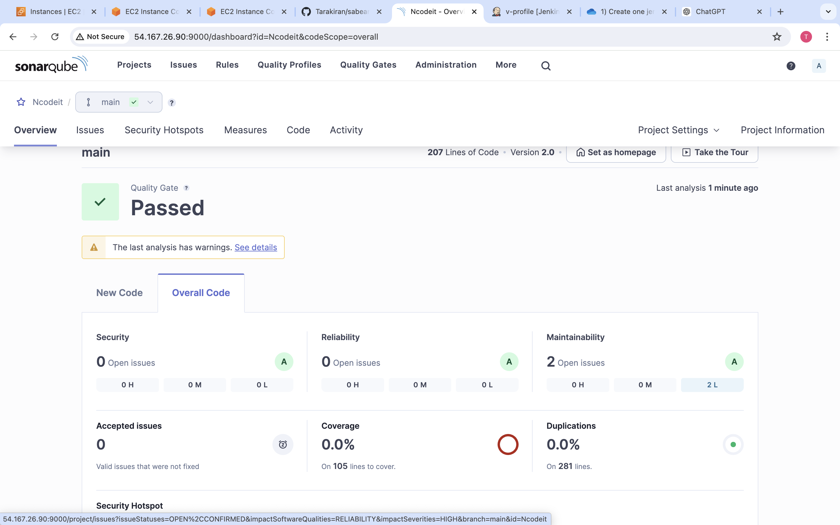

For slack integration you have to install slack plugin in jenkins

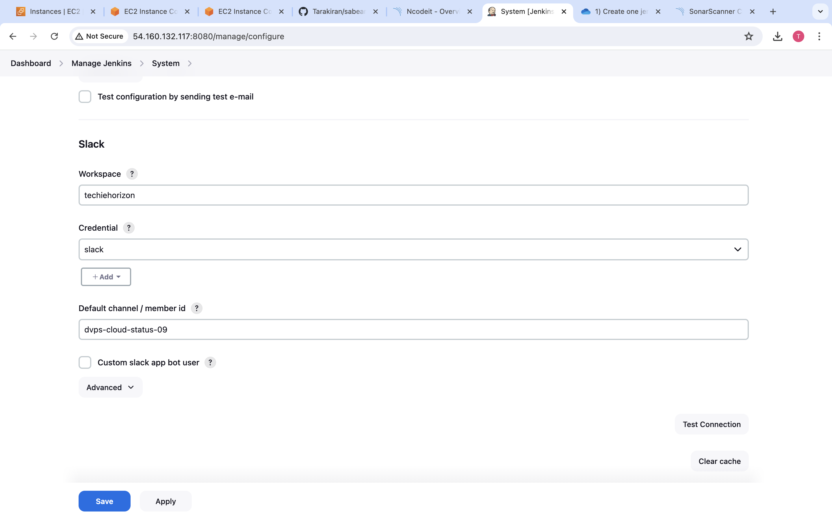

Add post build actions

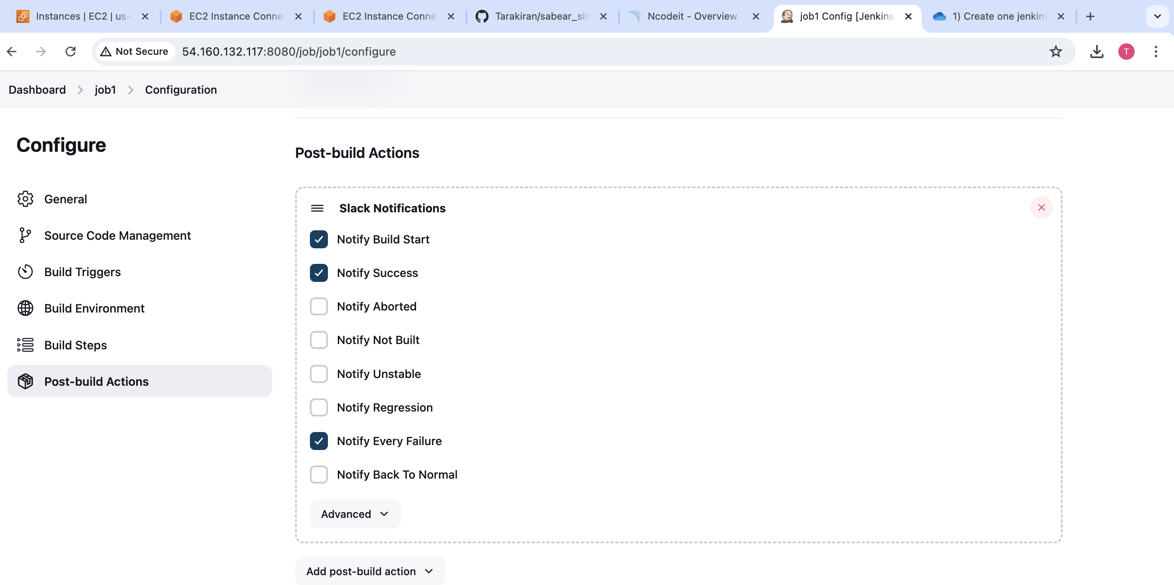

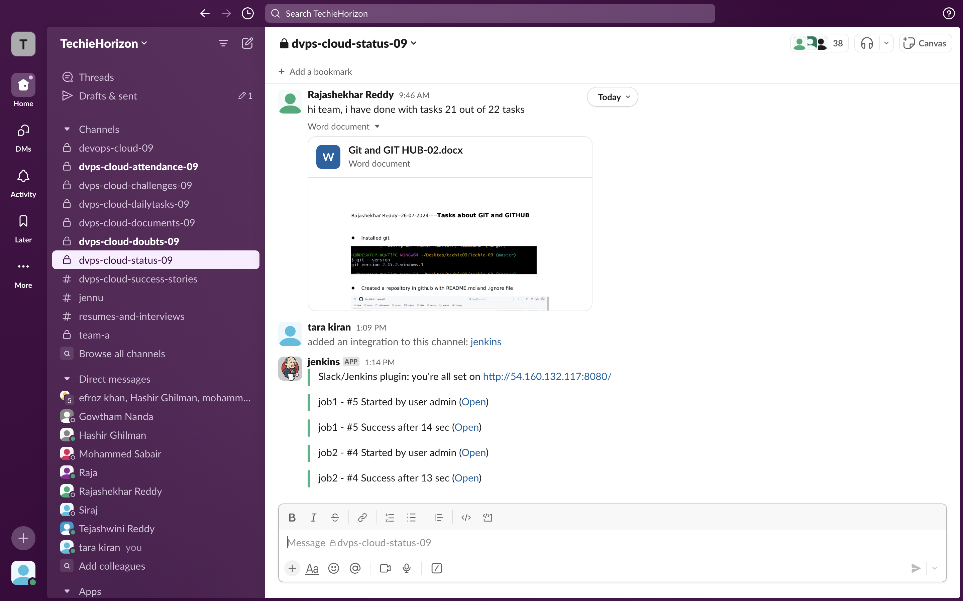

2) 1) Create one jenkins job using the below code and create three stages.

stage1: Git clone to download the source code.

stage2: Sonarqube Integration to check the quality of code

stage3: Slack Integration to send the alerts to slack.

URL: <https://github.com/betawins/hiring-app.git>

